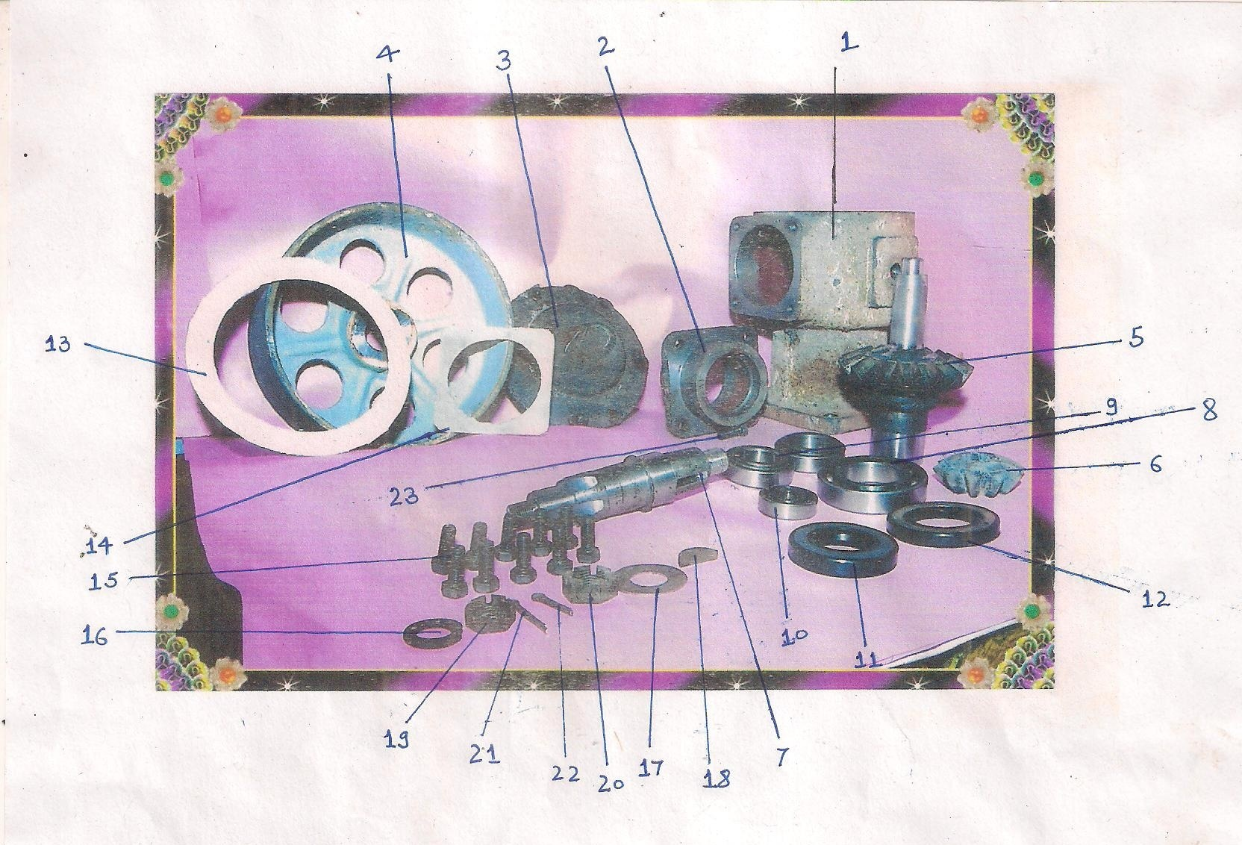
“ LIST OF PTO PULLEY COMPONENTS “

- Housing-I ( Raw structure for PTO Pulley)
- Housing-II ( “ NAL”)
- Housing-III ( Lid for “NAL”)
- Wheel Drum
- Big Gear
- Small Gear
- Pinion
- Bearing (Size-1)
- Bearing (Size-2)
- Bearing (Size-3)
11. Oil Seal (Size-1)
12. Oil Seal (Size-2)
13. Paper Gascut
14. Paper Gascut
15. Bolts
16. Spring Washer
17. Flat Washer
18. Key
19. CheckNut (Size-1)
20. CheckNut (Size-2)
21. Quarter Pin (Size-1)
22. Quarter Pin (Size-2)
23. Oil Stopper

